In 1880, brothers Pierre and Jacques Curie demonstrated the relationship between a mechanical load on a crystal (they worked with tourmaline, quartz, and Rochelle salt) and the electric charge resulting from it. Piezoelectricity is a linear electromechanical interaction between the mechanical and electrical states of crystals with no symmetric centers. The crystals can have one or more polar axes along which the effect occurs.

The piezoelectric effect results from a deformation of the crystal lattice by some external force that pushes the positive and negative lattice points against one another and thus produces a dipole moment. Depending on the orientation of the axes with respect to the applied force, three different types of effect can be discerned (see Figure 5).

|  |
| --- |
| figure  Figure 5. The way the quartz crystal is sliced (see Figure 1) determines the behavior of the finished sensing element. The piezoelectric effect can take one of three forms: longitudinal (A), transverse (B), or shear (C). |

**Longitudinal Effect.** The size of the charge depends only on the force applied. The only way to increase this charge is to connect several plates mechanically in series and electrically in parallel. If this is done, the charge is:

Qx = d11 × Fx × n

where:  
d11 = piezoelectric coefficient (for quartz crystal, d11 = ?2.30 pC/N)<  
F = applied force  
n = number of crystal plates  
x = direction of applied force

**Shear Effect.** This effect, too, is independent of the size and shape of the piezoelectric element as well as of the charge distribution. The charge occurs at the surfaces under load; at n elements connected mechanically in series and electrically in series is:

Qx = 2 × d11 × Fx × n

**Transverse Effect.** In this case, a force in the direction of one of the neutral axes produces a charge on the surfaces of the corresponding polar axis. The magnitude of the charge is dependent on the geometrical dimensions of the piezoelectric element. Assuming dimensions a, b, and c, the charge is:

Qy = ?d11 × Fy × b/a

where:  
y = a neutral axisThis material, and the caption for Figure 1, were excerpted from Measuring with Crystals, Bernhard Bill, tr. Peter Wareham, 2002, Verlag Moderne Industrie.

**4.3.3 Example: Piezoelectric Sensors**

As mentioned previously, a common implementation practice is to sandwich a piezoelectric crystal between two metal plates. Figure [26](http://soundlab.cs.princeton.edu/learning/tutorials/sensors/node15.html#piezoEquiv) shows an equivalent electrical circuit of this arrangement. The voltage source represents the voltage that develops due to the excess surface charge on the crystal. The capacitor which appears in series is due to the capacitor formed by the metallic plates of the sensor. An important point to make is that piezo sensors cannot be used to measure a constant force, but rather is only useful for dynamic forces. If one is familiar with basic circuit theory, it should be clear that the capacitor blocks the direct current (the constant voltage resulting from a constant force).

   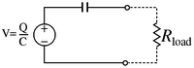

**Figure 26:** A piezoelectric sensor with a load resistance

In order to measure the force, one must measure the voltage which appears across the terminals of the sensor. It is impossible to measure voltage without drawing at least a little electrical current. This situation is summed up in Figure [26](http://soundlab.cs.princeton.edu/learning/tutorials/sensors/node15.html#piezoEquiv) where tex2html_wrap_inline1926 represents the load impedance inherent in the measuring device. Figure [27](http://soundlab.cs.princeton.edu/learning/tutorials/sensors/node15.html#piezoResp) shows a typical response which might arise if a constant force is applied to the piezo. In the absence of a load resistance, a force applied to the crystal will develop a charge which will remain as long as the force is present. In the case where the load resistor is present, an electrical path is formed which serves to allow the charge to dissipate, which in turn reduces the voltage. The higher the value of the resistance, the longer it will take for the charge to dissipate. The *time-constant* of the system is defined as the time it takes the charge (or voltage) to decrease to approximately 37its original value. The time constant tex2html_wrap_inline1928 is give by tex2html_wrap_inline1930 . Typical values for common piezo sensors is about tex2html_wrap_inline1932 ( nano-farads), and typical input impedances for measuring devices is on the order of tex2html_wrap_inline1934 ( mega-ohms). These values result in a tex2html_wrap_inline1928 of tex2html_wrap_inline1938 . Roughly speaking, this means that forces that are constant, or vary slowely will suffer from the fact that the voltage across the sensor will tend to decrease in amplitude, and the overall amplitude of the measure voltage will be reduced. Alternatively, forces which vary rapidly will not be subject to much if any decrease in amplitude.

   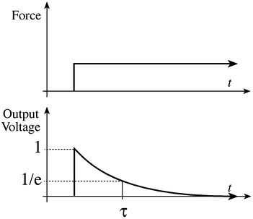

**Figure 27:** Time domain response of the output of a piezo sensor subject to a constant force

   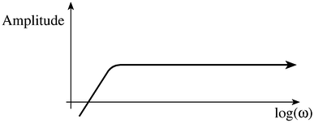

**Figure 28:** Frequency response of a piezo sensor

This situation can also be described in the *frequency domain*. In the time domain, the system is characterized by its time constant whereas in the frequency domain it is characterized by its cutoff frequency tex2html_wrap_inline1940 . A plot of the frequency response of piezo sensor along with a load resistance is shown in Figure [28](http://soundlab.cs.princeton.edu/learning/tutorials/sensors/node15.html#piezoResp2). For the sensor mentioned earlier with an internal capacitance of tex2html_wrap_inline1942 and a load resistance of tex2html_wrap_inline1934 , the cutoff frequency is equal to tex2html_wrap_inline1946 . Specifically, this means that a force varying at a frequency oftex2html_wrap_inline1946 will result in a measured voltage which is tex2html_wrap_inline1950 less than a more rapidly varying force with the same amplitude. In many applications it is important to make the tex2html_wrap_inline1950 frequency as low as possible. In order to do this one must make the input impedance of their measuring circuit as high as possible. Thus a non-inverting amplifier is connected to the piezo output as shown in Figure [29](http://soundlab.cs.princeton.edu/learning/tutorials/sensors/node15.html#piezoAmp).

   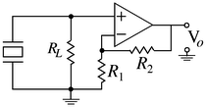

**Figure 29:** Amplified piezo sensor

Hence the circuit amplifies the voltage by the factor tex2html_wrap_inline1954 . The tex2html_wrap_inline1950 cutoff frequency of this circuit is tex2html_wrap_inline1958 , where *C* is the internal capacitance of the sensor. It is clear that an increase in the value of the input resistor will result in a decrease in the cutoff frequency.